1. AIM TO: Design DFA using simulator to accept strings in which a’s always appear tripled over input {a,b}

INPUT:

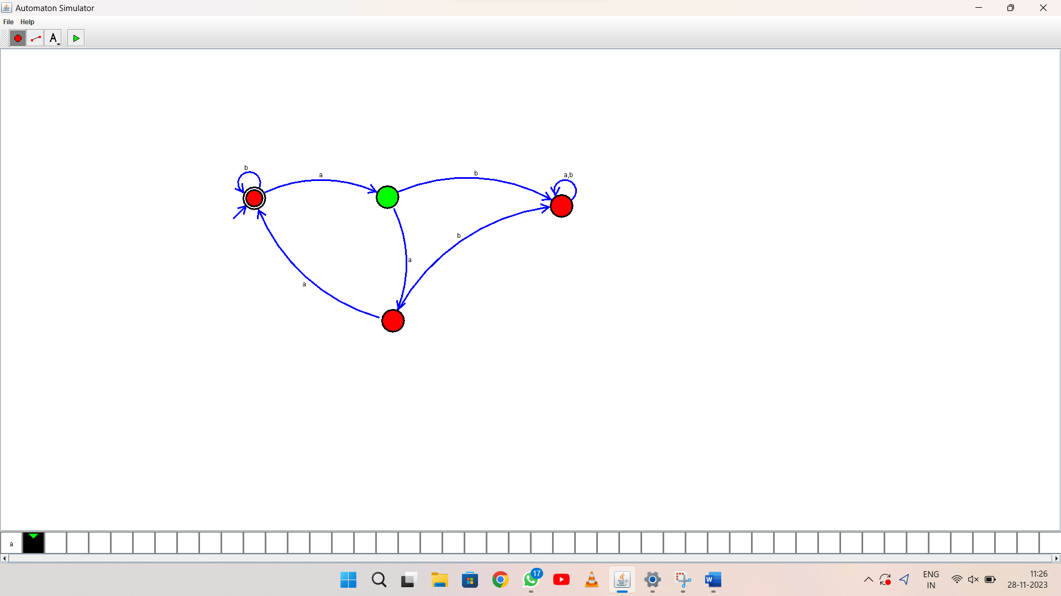

OUTPUT:

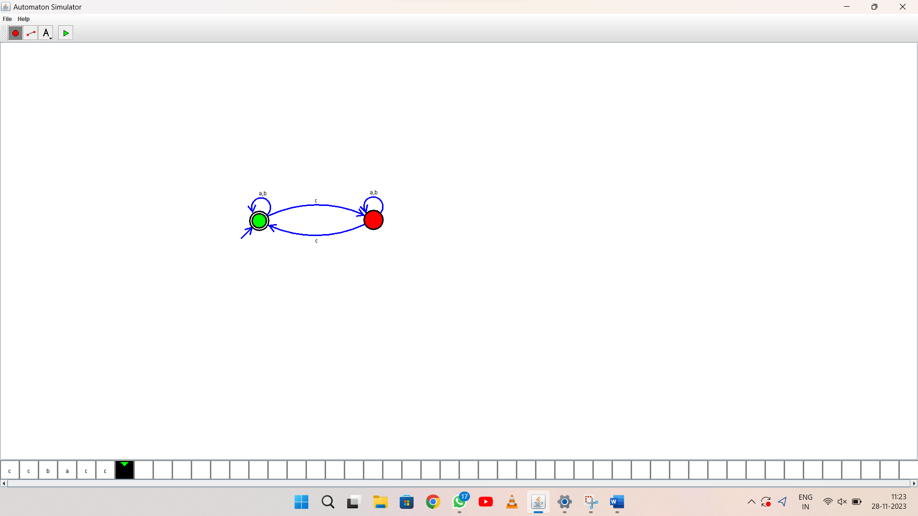

1. RESULT: thus Design DFA using simulator to accept the string the end with ab over set {a,b)

W= aaabab